**BSCP 2023 MEMBERSHIP APPLICATION FORM**

**Please Print Clearly**

Name(s): ___________________________________

___________________________________

Address: ___________________________________

___________________________________

Apt. #_______

City: ___________________________________

State: ______ Zip Code: _____________

Phone: ( ) ____________________

Email (s): ___________________________________

___________________________________

Date: ___________________________________

Please mail form and **$20** per person check payable to **BSCP** to:

BSCP, 2800 Locust Lane, Harrisburg, PA17109

Membership is also available on our web-site (PayPal or credit card), at the Jam and events.

**Weekly Thursday Night Blues Jam**

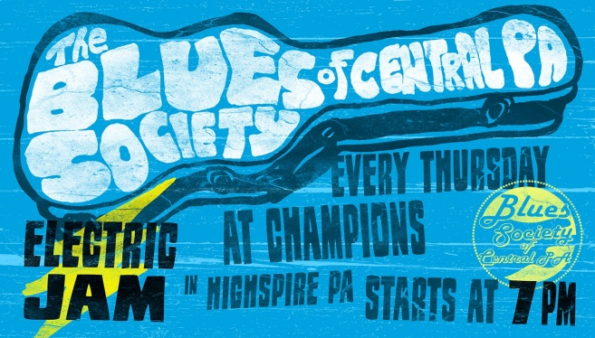

**Champions Sports Bar & Grill**

**300 2nd Street, Highspire, PA**

|  |
| --- |
|  |

**CONTACT INFORMATION**

**Facebook: Blues Society of Central Pennsylvania**

**Blues Society of Central PA Group Page**

[**www.BSCPblues.com**](http://www.BSCPblues.com)

**Instagram: bluessocietycentralpa**

**bluesmunga@gmail.com**

**Love the Blues?**

**Dedicated to the preservation, promotion, support and enjoyment of the truly original American art form, the BLUES**



**BSCP MERCHANDISE AND CD “BACKYARD BLUES” AVAILABLE AT EVENTS AND ON WEBSITE**

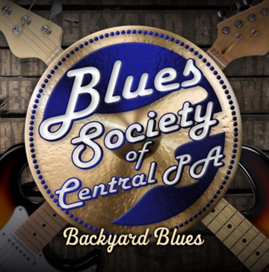

A collection of original music featuring

16 songs from 9 regional blues artists/bands.

|  |
| --- |
| **BSCP MEMBERSHIP BENEFITS**   * Free admission to Christmas Party * Free admission to Mississippi Railroad * Free newsletter * Notification of all BSCP events |

**ANNUAL BSCP MUSIC EVENTS**

**Winter, Spring, and Fall Shows** are seasonal celebrations of the blues featuring local, regional and/or national artists/bands.

**Mom I’s Picnic** is the BSCP annual fundraiser with a picnic food and beverage buffet featuring music by local bands.

**Mississippi Railroad** features a blues artist from Mississippi honoring the BSCP roots with Delta and Mississippi Hill Blues.

**Memorial Jam** honors recently deceased jam musicians and provides a legacy through donations to the Education Committee.

**Christmas Party** is a time to celebrate the holidays with a holiday dinner buffet followed by dancing to a regional or national band.



**JOIN US FOR SHOWS, PICNICS AND PARTIES**

