BLUES SOCIETY OF CENTRAL PENNSYLVANIA
GENERAL MEETING MINTUES
December 13, 2022 @ 7 pm

ATTENDANCE
Board Members: John (JD) Drudul, Tyler Faulkner, Kathryn Gregoire, Joe Kambic, Mike Knott, Valerie McCaffrey, Dan Mowery, John Rignani, Gary (Rocky) Rothrock, Hannah Sherman, Sherman Smith, Rebecca Young
Excused: Mike Easton, Tyler Faulkner
General Members: Lewy Bechtold, Sallie Bengtson, Greg Hogg, Christy Lerch, Keshev Rao
CALL TO ORDER RECORD meeting ICLOUD
MINUTES – November 8, 2022. Motion (Rothrock/Kambic) to approve Minutes passed unanimously
OLD BUSINESS None
NEW BUSINESS
ELECTION OF OFFICERS Treasurer Gary “Rocky” Rothrock conducted the elections for the President, Vice-President, and Secretary for terms of one year. All participating in the election process were members in good standing (have 2022 memberships). Rothrock invited nominations from the floor. There were none. He asked Gregoire if there were any by mail. There were none.
Rothrock presented the BSCP BOD Nominations Committee slate of officers: Secretary - Lewis Bechtold, Vice-President – Mike Knott and President - Kathryn Gregoire. Rothrock called for votes for Bechtold for Secretary: All in favor. Rothrock called for votes for Knott for Vice-President: 1 opposed, the rest in favor. Rothrock called for votes for Gregoire for President: 1 opposed, the rest in favor.
Gregoire stated that Mike Heiman, Paula Heiman, Dot Grubb, and Buster Grubb submitted their votes in favor for the nominees on the BSCP BOD slate of officers. Hannah Sherman stated that Al Mamola and Mary Mamola submitted their votes in favor for the nominees on the BSCP BOD slate of officers.
Rothrock declared the majority of the votes were in favor for Bechtold for Secretary, Knott for Vice-President, and Gregoire for President for 2023.
The BSCP BOD will vote on the Treasurer at the January 2023 meeting. The President will appoint the Committee Chairpersons at the January meeting.
Rothrock declared election concluded.

BY-LAW REVISIONS
By-Laws Committee Chairperson Joe Kambic conducted voting on By-Law revisions passed by BSCP BOD at the November 8, 2022, meeting and brought to the 2022 General Meeting for a vote by general membership.
Kambic presented the recommended revisions for a vote one ARTICLE at a time.
Kambic presented revisions.
Motion (Rothrock/Sherman) made to accept a revision to ARTICLE I – DEFINITION. Approved.
Motion (Rothrock/Sherman) made to accept revisions to ARTICLE II - PURPOSE. Approved.
Motion (Knott/Sherman) made to accept revisions to ARTICLE III - MEMBERSHIP. Approved.
Motion (Kambic/Rothrock) made to accept revisions to ARTICLE IV - OFFICERS. Approved.
Motion (Knott/Sherman) made to accept revisions to ARTICLE V – BOARD OF DIRECTORS. Approved.
Motion (Rothrock/Knott) made to accept revisions to ARTICLE IX – COMMITTEES. Approved.
Motion (Rothrock/Sherman) made to accept revisions to ARTICLE XI - DUES. Approved.
Motion (Knott/Sherman) made to accept a revision to ARTICLE XIII. Approved.

BSCP BOARD OF DIRECTORS 2022 ANNUAL REPORT
2022 BSCP President’s Report by Kathryn Gregoire
There are currently 13 members on the BOD. New members in 2022 included Ben Brandt, Carrie Baker, Mike Easton, Tyler Faulkner, Joe Kambic and Valerie McCaffrey. Returning board members included John ‘JD’ Drudul, Kathryn Gregoire, Mike Knott, Dan Mowery, John Rignani, Gary “Rocky” Rothrock, Hannah Sherman, Sherman Smith and Rebecca Young.
Early in 2022 Carrie Baker, Greg Hogg, Betty Knott, and Rosemary Witzel resigned from the board. BSCP is appreciative of Carrie Baker who was a founder of the society and has served BSCP BOD in many roles, most recently in 2022 as BSCP Secretary and chairperson of the Archives committee. BSCP congratulates Greg Hogg for his 15 years of service on the board, most recently as a Member-at-Large. He is especially recognized for his leadership of the International Blues Challenge committee and for the good will he has generated over the years with other blues societies and welcoming new members to BSCP. Greg organized the Tri-State Blues Showcase held this past year at Champions. He provides a pictorial history of BSCP on BSCPblues.com and valued photographs for the BSCP newsletter. BSCP is grateful to Betty Knott for her work as BSCP secretary and for her hours of proofreading Blues News, which she continues to do. She also continues to volunteer at the Christmas Party and the annual picnic. Rosemary Witzel served as a Member-at-Large during 2021 and for several years as a volunteer at the Mom I Picnic and the Christmas Party. Thank you, Rosemary, for your many hours of dedicated work.
Ben Brandt, Member-at-Large, resigned near the end of 2022. Tyler Faulkner and Joe Kambic have resigned their positions as Board Directors effective December 31, 2022. BSCP is very appreciative of the work Tyler Faulkner did as BOD secretary faithfully and accurately writing meeting minutes and Joe for his leadership role in revising the by-laws as chair of the By-Laws Committee and in developing Master Classes which were offered by BSCP in Central PA while Chair of the Education Committee. He serves as secretary of the newly formed NE Blues Societies Consortium. Thank you, Ben Brandt, for serving as a Member-at-Large in 2022.
BSCP supported music events in Central PA in 2022, most notably the East Petersburg Blues Festival and Susquehanna Folk Music Society events.
BSCP is a founding member of the NE Consortium of blues societies, along with Long Island Blues Society, Hudson Bay Blues Society and North New Jersey Blues Society. The Consortium serves as a source of support for the blues societies and their work.
BSCP works in cooperation with NOLA Blue record label company to jointly bring blues artists to the local area. BSCP also worked with a Penryn church pastor to bring three blues shows to the community.
BSCP developed partnerships with SFMS and XL Live. BSCP members receive a discount on selected blues shows in exchange for email promotion by BSCP.
BSCP is a member of The Blues Foundation and contributes to Music Makers Foundation annually.
2022 BSCP Treasurer/Finance Committee Report by Gary “Rocky” Rothrock
Checking Balance is $19,884.46. Revenue this year so far included $4.496 in memberships, $8,188 in jam jar contributions, $1,382 in merchandise sales, $9,779 in events income and $2,646 in donations, for a total of $26,600. Expenses paid this year totaled $20,046, for a gain so far of $6.554.
Our largest expense were $7,190 in performance fees to musicians, $3,937 for the Mom I Picnic, $2,499 in merchandise purchases, $1,831 in printing and $1000 donation to MusicMakers Foundation. We also spent $800 to sponsor other blues events in the area.
The PayPal balance is $0 and the Mitch education fund is $2,210.00.
Our Fiscal Year ends on June 30 of each year and we showed a gain of $4797.61 for the fiscal year, with income of $25,504.71 and expenses of $20,707.10.
2022 BSCP By-Laws Committee Report by Joe Kambic
The Committee reviewed and made recommendations to the BOD who forwarded their recommendations to the general membership for voting at the annual December meeting. Committee members include Mike Knott and Kathryn Gregoire (ex-officio).
2022 BSCP Education Committee Report by Joe Kambic
BSCP is now offering Master Classes in various live venues. Teresa James, a Grammy nominee and a Blues Music Award nominee, presented Blues Singing and Improvisation at Mulberry Art Studios free for the public in Lancaster, PA, on June 19, 2022.
The award-winning Texas Horns, who play with such legends as Jimmie Vaughn and Steve Davis, gave a free Master Class on horns for students in the Lancaster City School District on July 25, 2022.
Roman Barten-Sherman, an extraordinary guitar player and vocalist who performed on Zoom for BSCP during the pandemic (see BSCPblues.com), provided a free two-hour Master Class on Finger-Picking on Zoom on August 12, 2022.
Dan Mowery, BSCP Webmaster, is posting the recordings of the Master Classes on our new BSCP YouTube channel and our BSCPblues.com website. Plans are underway for future Master Classes.
Mike Knott served on a panel representing BSCP at a seminar on Event Bookings/Promotions at Lebanon Valley College, Annville, PA, on Saturday, November 19, 2022.
Other blues education activities include the donation of musical instruments to students, the monthly meetings of our BSCP Blues Book Club on Zoom, and the newly-launched BSCP Blues Book Library program.

During 2022, the BSCP Blues Book Club met on Zoom the third Monday of every month at 11 am to discuss the following books: I Ain’t Studdin’ Ya: My American Blues Story by Bobby Rush with Herb Powell; Father of the Blues: An Autobiography by W.C. Handy; Black Swan Blues by Paul Slade; His Eye Is On The Sparrow: An Autobiography by Ethel Waters with Charles Samuels; The Life and Legend of Leadbelly by Charles Wolfe and Kip Lornell; and I Am Blues: The Willie Dixon Story by Willie Dixon with Don Snowden.
Book club members enjoyed musical input from Hank Imhoff and Tom Cook, related videos and films and learned a great deal from much lively discussions. Book club members got to meet on a Baltimore tour of the Fell’s Point area and the historic Federal Hill on October 26, 2022.
BSCP is developing a traveling lending library for the jam and events and welcomes donations of blues books, videos and music.
2022 BSCP Public Relations Committee Report by Rebecca Young
The goal of the Public Relations Committee, chaired by Rebecca Young, is to drive awareness of BSCP within the local area and blues community, encourage new membership, and engage with our current membership.
With the return to in-person Jams and events, we have been utilizing the BSCP official Facebook page to advertise our weekly Jams, shows, and special events as well as promote online merchandise sales and newsletter updates. We are using the member created BSCP group Facebook page to gain additional exposure for BSCP events and news. The page was created as a way for members to communicate and share relevant content, and it continues to be a forum for conversation regarding all things blues.
This year we welcomed Jay McElroy, a graphic artist and designer, who is creating original artwork for our events posters, flyers, and social media content.
In July, Kathryn Gregoire represented BSCP on Good Day PA, a daily lifestyle program airing on ABC Channel 27 to generate community awareness for BSCP and to promote the weekly Jam and upcoming events. We were also able to have two of our members, Bob Wineland and Rocky Rothrock, perform an acoustic set of live blues. These videos are available on our website if you missed it. We look forward to scheduling future segments in the upcoming year.
As we approach 2023, we will be focused on deploying new ways to connect and engage with the community beyond Facebook, email, and our website. We currently have a monthly ad in the PA Musician Magazine as well as an ad in the Lancaster Roots and Blues program.
Public Relations Committee members include Valerie McCaffrey, Tyler Faulkner, Joanne Iskandarani and Kathryn Gregoire (ex-officio).
Make sure that you like and follow us on Facebook to stay up to date on the latest news and events from the Blues Society of Central PA. Please reach out to any board member if you are interested in volunteering or have feedback or suggestions on how to spread the word about BSCP.

2022 BSCP Events Committee Report by Mike Knott.
The BSCP held 5 shows and 1 picnic in 2022
Winter Show: A Tri-State Blues Showcase – Billy Pierce Band, Sister Blue with Shakey Lyman, and the Don Evans Band held on Sunday, February 6, at Champions Sports Bar in Highspire, Pa.
Spring Show – Lil Ed & the Blues Imperials with Benjamin Vo Band opening
Held Sunday April 24 at Champions Sports Bar in Highspire, Pa.
Mom I Picnic – Nate Myers Trio, The Humblers, Ben Brandt & Soul Miners Union, Don Johnson Project, Electric Stew, and the Mighty Klucks.
Our annual fund raiser which included a food buffet and beer truck was held
Sunday May 5 at the Mechanicsburg Club’s picnic grounds
Mississippi Railroad – Anthony “Big A“ Sherrod with the Cornlickers
The “free to members” event was held Sunday July 17 at Champions Sports Bar in
Highspire, Pa.
Fall Show- Gabe Stillman/Ben Brandt & Soul Miners Union
Held Sunday Sept. 18 at Champions Sports Bar, in Highspire, Pa.
Christmas Party – King Solomon Hicks Band
The “free to members” event that included a food buffet was held Sunday
December 4 at the Hummelstown Fire Hall, in Hummelstown, Pa.
Plans for 2023 will include a Winter Show, Spring Show, Mom I Picnic, Mississippi Railroad Show, Fall Show and a Christmas Party.
Committee members include Hannah Sherman, Sherman Smith, Gary “Rocky” Rothrock, and Kathryn Gregoire (ex-officio)

2022 BSCP Merchandise Committee Report by John Rignani
We have completed ramping back up to hosting a full slate of live events again this past year! Though the turn-out has been less than pre-Covid level, the enthusiasm has been encouraging none the less.
Our merch offerings are set to expand greatly in 2023 with the Society’s promotion of our 25th Anniversary themed apparel. Beginning with our 2022 Christmas Show, we will have several new designs to choose from. These have been developed through collaboration with our good friend and past graphic designer extraordinaire, Rocky Woodling. I hope that these new offerings will be well received by the Society’s fans.
Gross revenue generated in 2022 from merch sales on-line and from live events was $1,438.00 in 2022.
The Committee’s goal remains to provide a fun and affordable enhancement towards the growth of the Society and to its Members.
Committee members include Kent Seidel and Kathryn Gregoire (ex-officio).

2022 BSCP Newsletter Report by Kathryn Gregoire
Four quarterly newsletters were written, printed and distributed in digital and paper format. They are posted on the BSCPblues.com website in 2022. Newsletters are typically 16 pages in length. New features include “Meet Your Board Members,” “Tech Corner,” and “Jammin’ with JD.” BSCP members contributed a variety of feature stories, CD Reviews and photographs.
Newsletter Committee members include Hannah Sherman, Mike Knott, Betty Knott, Jackson Fogel. Multiple members contribute articles and photographs each issue.

2022 BSCP Website Committee Report by Dan Mowery
Website Enhancements
- Updated landing page (New background image and featured content)
- Expansion of Videos section
  - Masterclass Workshop videos
  - Good Day PA performances
  - Live Jam @ Champions
  - NYE 2021 Virtual Jam video
- BSCP YouTube channel created to host videos found above and to promote multiple contributors
- BSCP Store refresh with 25th Anniversary merchandise
- Online ticket sales for BSCP sponsored events

Website Traffic
- Total Sessions: 4695 (up 25% from last year)
- Unique Visitors: 2736 (up 13% from last year)
- Sessions by Device:
  - Desktop: 1765 (38%)
  - Mobile: 2694 (59%)
  - Tablet: 127 (3%)
- New vs: Returning Visitors:
  - New: 2619
  - Returning: 117

Top Pages
- Homepage: 2587 (down 5%)
- Upcoming Events: 1234 (up 51%)
- Featured Event: 750 (up 121%)
- Upcoming Events Calendar: 689 (up 54%)

Top Traffic Sources
- Direct: 1203 (down 4%)
- Google.com: 2397 (up 68%)
- Facebook: 373 (down 19%)
- Unknown: 320 (down 28%)
- App.display.stream 145

Traffic over time:
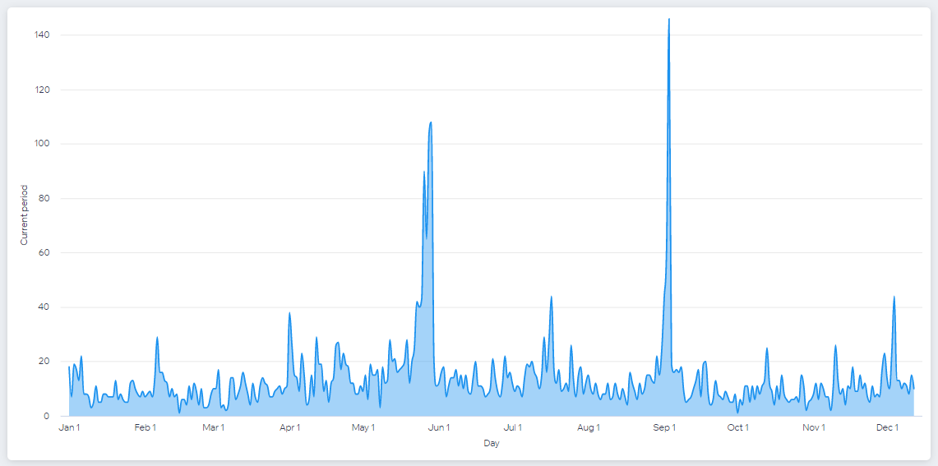

Videos views over time vs: last year:
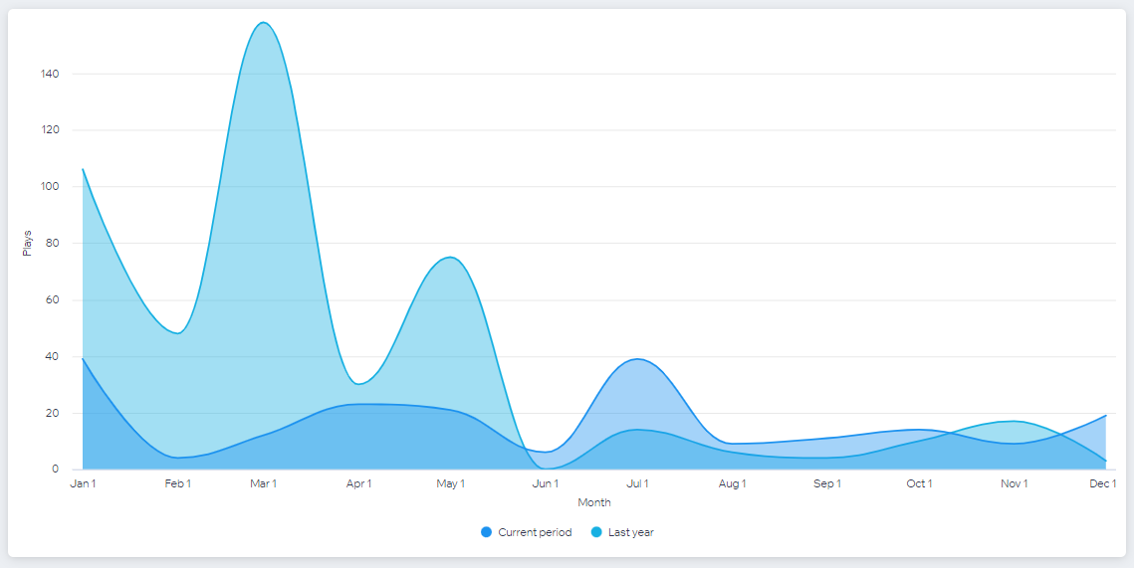

eCommerce
- Total Sales: $5191 (up 302%)
- Avg Order: $31.65 (up 30%)
- Total Orders: 164 (up 209%)

- Top Selling Items
  - BSCP Mom I Picnic: $2920 online sales
  - BSCP Spring Show/Lil’ Ed online sales: $800
  - 2023 Membership: $565
  - BSCP Fall Show/Gabe Stillman: $396
  - 2022 Membership: $210

- Sales by Traffic Source
  - Google: $1637
  - Other: $283
  - Direct: $1664
  - Unknown: $985
  - Facebook: $765

eCommerce Traffic
- Customers: 139 vs: 89 last year
- Customer Retention: New 86%, Returning 14%
- New Site Members: 12 (down 58%)
- Active Leads: 44 (up 38%)
Site Uptime and Security
- Yearly uptime: 99.98%
- SSL Certificate
- TLS 1.3 Encryption
- DDoS Protection
- Level 1 PCI Compliance

Site Speed
- Rated Average: 2.5 seconds to load

Insights and Opportunities
- The percentage of sessions with product views was 17%. That is higher than average for sites like ours.
- Add to cart rate is 28%, also higher than average.
- Checkout rate is 89%, also higher than average.
- People spend the most time on the upcoming events calendar (Thanks Mike!!)

IT:
- Assisted musicians and members with Zoom setup when needed.
- Created articles for the quarterly newsletter, including Tech Corner, Blues Trail trips, and jam reviews from other areas of the country.
- Researched and setup the weekly jam message board and continue to maintain it and do weekly updates.

Website Committee includes John “JD” Drudul and Kathryn Gregoire (ex. Officio).

2022 BSCP Jam Committee Report by Gary “Rocky” Rothrock
Our jam is going well and jam jar proceeds have been good. We continue to see new jammers showing up, many of them younger people.
We have had some repairs this year, but no major new gear was needed. One guitar amp is in the shop. but Don Intrieri has loaned us a replacement while it is being repaired. Don has been a great help to us at the jam and otherwise. Shout out to our jam hosts Marianna Schaffer, John Stover, Jamie Hess, Lewy Dean, Bob Wineland, George Bressler, and Tom Lowry, as well as all those who help set up and tear down every week!

BSCP held a memorial jam from 6 pm – 11 pm on October 20, 2022, to celebrate the musicians and friends who passed away over the pandemic years including Gary Harrington, Tony Formica, Blaine Weiser and Chad Salvaggio. Members of their former bands - Nate Myers and the Aces, Slaughterhouse Blues and the Howlers played amazing sets for a packed house! Jam jar proceeds were dedicated to the Mitch Ivanoff Education fund.

2022 BSCP Archive Committee Report by Mike Easton
Newly appointed Archive Committee Chairperson Mike Easton will be heading the 25th Anniversary Celebration in 2023. BSCP Blues News features archive topics quarterly in “A Peek at the Past.”
Archive Committee includes Hannah Sherman and Kathryn Gregoire (ex-officio)

2022 BSCP Membership Committee Report by Kathryn Gregoire
There are 281 members for 2022, an increase of 56 members from 2021. The committee chair initiated a non-membership email list with approximately 88 names so far.
BSCP raised the cost of membership from $15 to $20 for 2023. Memberships continue to be sold at the BSCP Thursday Jam, BSCP events and online at the BSCP website.
John Rignani developed a membership packet to send out to new members and Kathryn Gregoire updated our brochure to provide information about BSCP and membership.
Membership committee members include Buster Grubb, Dot Grubb, Christina Beusch and John Rignani.

ADJOURNMENT The meeting adjourned 8:20 pm.

